# Building the Node.js Web Application Framework with Express Framework

## Express Overview

Express is a minimal and flexible Node.js web application framework that provides a robust set of features to develop web and mobile applications. It facilitates the rapid development of Node based Web applications. Following are some of the core features of Express framework −

* Allows to set up middlewares to respond to HTTP Requests.
* Defines a routing table which is used to perform different actions based on HTTP Method and URL.
* Allows to dynamically render HTML Pages based on passing arguments to templates. We can pull information from a database and send that information back to the Web page. And we can get information from the HTML form and use that user-provided form data to construct our SQL Statements.

## Installing Express

Firstly, install the Express framework globally using NPM so that it can be used to create a web application using node terminal.

$ npm install express --save

The above command saves the installation locally in the **node_modules** directory and creates a directory express inside node_modules. You should install the following important modules along with express −

* **body-parser** − This is a node.js middleware for handling JSON, Raw, Text and URL encoded form data.
* **cookie-parser** − Parse Cookie header and populate req.cookies with an object keyed by the cookie names.
* **multer** − This is a node.js middleware for handling multipart/form-data.

$ npm install body-parser --save

$ npm install cookie-parser --save

$ npm install multer --save

## Hello world Example

Following is a very basic Express app which starts a server and listens on port 8081 for connection. This app responds with **Hello World!** for requests to the homepage. For every other path, it will respond with a **404 Not Found.**

var express = require('express');

var app = express();

app.get('/', function (req, res) {

res.send('Hello World');

})

var server = app.listen(8081, function () {

var host = server.address().address

var port = server.address().port

console.log("Example app listening at http://%s:%s", host, port)

})

Save the above code in a file named server.js and run it with the following command.

$ **node server.js**

You will see the following output −

Example app listening at http://0.0.0.0:8081

Open http://127.0.0.1:8081/ in any browser to see the following result.

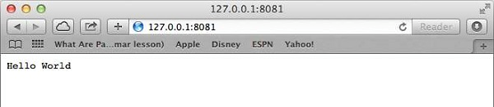

## Request & Response

Express application uses a callback function whose parameters are **request** and **response** objects.

app.get('/', function (req, res) {

// --

})

* [Request Object](https://www.tutorialspoint.com/nodejs/nodejs_request_object.htm) − The request object represents the HTTP request and has properties for the request query string, parameters, body, HTTP headers, and so on.
* [Response Object](https://www.tutorialspoint.com/nodejs/nodejs_response_object.htm) − The response object represents the HTTP response that an Express app sends when it gets an HTTP request.

You can print **req** and **res** objects which provide a lot of information related to HTTP request and response including cookies, sessions, URL, etc.

## Basic Routing

We have seen a basic application which serves HTTP request for the homepage. Routing refers to determining how an application responds to a client request to a particular endpoint, which is a URI (or path) and a specific HTTP request method (GET, POST, and so on).

We will extend our Hello World program to handle more types of HTTP requests.

var express = require('express');

var app = express();

// This responds with "Hello World" on the homepage

app.get('/', function (req, res) {

console.log("Got a GET request for the homepage");

res.send('Hello GET');

})

// This responds a POST request for the homepage

app.post('/', function (req, res) {

console.log("Got a POST request for the homepage");

res.send('Hello POST');

})

// This responds a DELETE request for the /del_user page.

app.delete('/del_user', function (req, res) {

console.log("Got a DELETE request for /del_user");

res.send('Hello DELETE');

})

// This responds a GET request for the /list_user page.

app.get('/list_user', function (req, res) {

console.log("Got a GET request for /list_user");

res.send('Page Listing');

})

// This responds a GET request for abcd, abxcd, ab123cd, and so on

app.get('/ab*cd', function(req, res) {

console.log("Got a GET request for /ab*cd");

res.send('Page Pattern Match');

})

var server = app.listen(8081, function () {

var host = server.address().address

var port = server.address().port

console.log("Example app listening at http://%s:%s", host, port)

})

Save the above code in a file named server.js and run it with the following command.

$ node server.js

You will see the following output −

Example app listening at http://0.0.0.0:8081

Now you can try different requests at http://127.0.0.1:8081 to see the output generated by server.js. Following are a few screens shots showing different responses for different URLs.

Screen showing again http://127.0.0.1:8081/list_user

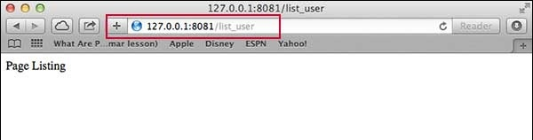

Screen showing again http://127.0.0.1:8081/abcd

Screen showing again http://127.0.0.1:8081/abcdefg

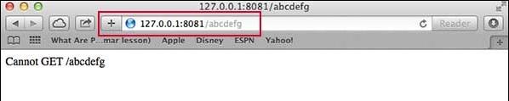

## Serving Static Files

Express provides a built-in middleware **express.static** to serve static files, such as images, CSS, JavaScript, etc.

You simply need to pass the name of the directory where you keep your static assets, to the **express.static** middleware to start serving the files directly. For example, if you keep your images, CSS, and JavaScript files in a directory named public, you can do this −

app.use(express.static('public'));

We will keep a few images in **public/img** sub-directory as follows −

node_modules

server.js

public/

public/img

public/img/studying.png

Let's modify "Hello Word" app to add the functionality to handle static files.

var express = require('express');

var app = express();

app.use(express.static('public'));

app.get('/', function (req, res) {

res.send('Hello World');

})

var server = app.listen(8081, function () {

var host = server.address().address

var port = server.address().port

console.log("Example app listening at http://%s:%s", host, port)

})

Save the above code in a file named server.js and run it with the following command.

$ node server.js

Now open http://127.0.0.1:8081/img/studying.png in any browser and see observe following result.

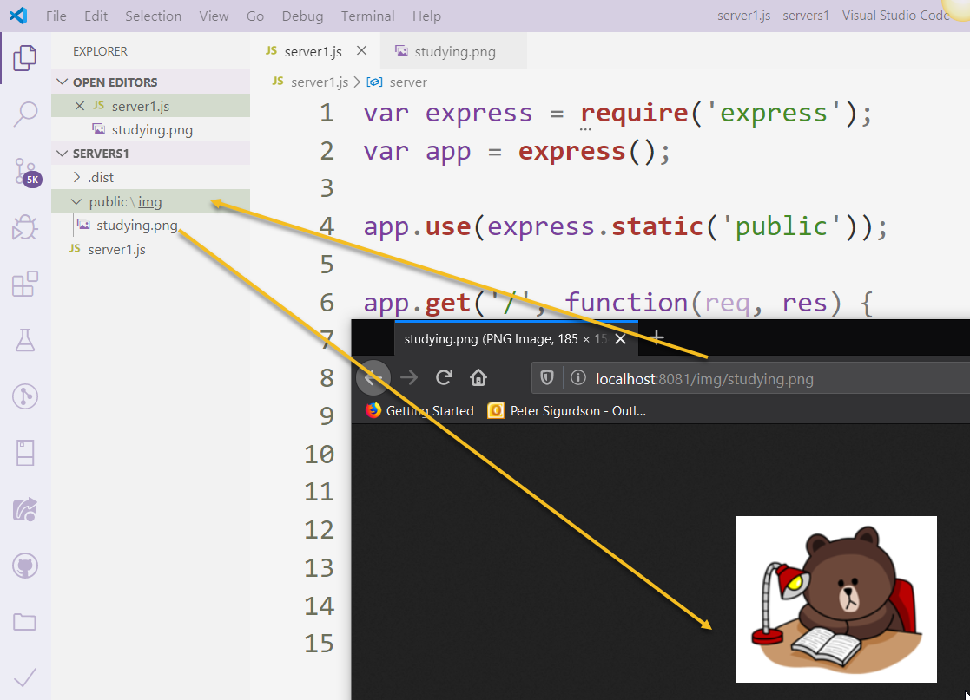

## GET Method

Here is a simple example which passes two values using HTML FORM GET method. We are going to use **process_get** router inside server.js to handle this input.

<html>

<body>

<form action = "http://127.0.0.1:8081/process_get" method = "GET">

First Name: <input type = "text" name = "first_name"> <br>

Last Name: <input type = "text" name = "last_name">

<input type = "submit" value = "Submit">

</form>

</body>

</html>

Let's save above code in index.htm and modify server.js to handle home page requests as well as the input sent by the HTML form.

var express = require('express');

var app = express();

app.use(express.static('public'));

app.get('/index.htm', function (req, res) {

res.sendfile( __dirname + "/" + "index.htm" );

})

app.get('/process_get', function (req, res) {

// Prepare output in JSON format

response = {

first_name:**req.query.first_name**,

last_name:**req.query.last_name**

};

console.log(response);

res.end(JSON.stringify(response));

})

var server = app.listen(8081, function () {

var host = server.address().address

var port = server.address().port

console.log("Example app listening at http://%s:%s", host, port)

})

Accessing the HTML document using *http://127.0.0.1:8081/index.htm* will generate the following form −

Top of Form

|  |  |
| --- | --- |
| First Name: |  |
| Last Name: |  |
|  | |

Bottom of Form

Now you can enter the First and Last Name and then click submit button to see the result and it should return the following result −

{"first_name":"John","last_name":"Paul"}

## POST Method

Here is a simple example which passes two values using HTML FORM POST method. We are going to use **process_get** router inside server.js to handle this input.

<html>

<body>

<form action = "http://127.0.0.1:8081/process_post" method = "POST">

First Name: <input type = "text" name = "first_name"> <br>

Last Name: <input type = "text" name = "last_name">

<input type = "submit" value = "Submit">

</form>

</body>

</html>

Let's save the above code in index.htm and modify server.js to handle home page requests as well as the input sent by the HTML form.

var express = require('express');

var app = express();

var bodyParser = require('body-parser');

// Create application/x-www-form-urlencoded parser

var urlencodedParser = bodyParser.urlencoded({ extended: false })

app.use(express.static('public'));

app.get('/index.htm', function (req, res) {

res.sendFile( __dirname + "/" + "index.htm" );

})

app.post('/process_post', urlencodedParser, function (req, res) {

// Prepare output in JSON format

response = {

first_name:req.body.first_name,

last_name:req.body.last_name

};

console.log(response);

res.end(JSON.stringify(response));

})

var server = app.listen(8081, function () {

var host = server.address().address

var port = server.address().port

console.log("Example app listening at http://%s:%s", host, port)

})

Accessing the HTML document using *http://127.0.0.1:8081/index.htm* will generate the following form −

Top of Form

|  |  |
| --- | --- |
| First Name: |  |
| Last Name: |  |
|  | |

Bottom of Form

Now you can enter the First and Last Name and then click the submit button to see the following result −

{"first_name":"John","last_name":"Paul"}

## File Upload

The following HTML code creates a file uploader form. This form has method attribute set to **POST** and enctype attribute is set to **multipart/form-data**

<html>

<head>

<title>File Uploading Form</title>

</head>

<body>

<h3>File Upload:</h3>

Select a file to upload: <br />

<form action = "http://127.0.0.1:8081/file_upload" method = "POST"

enctype = "multipart/form-data">

<input type="file" name="file" size="50" />

<br />

<input type = "submit" value = "Upload File" />

</form>

</body>

</html>

Let's save above code in index.htm and modify server.js to handle home page requests as well as file upload.

var express = require('express');

var app = express();

var fs = require("fs");

var bodyParser = require('body-parser');

var multer = require('multer');

app.use(express.static('public'));

app.use(bodyParser.urlencoded({ extended: false }));

app.use(multer({ dest: '/tmp/'}));

app.get('/index.htm', function (req, res) {

res.sendFile( __dirname + "/" + "index.htm" );

})

app.post('/file_upload', function (req, res) {

console.log(req.files.file.name);

console.log(req.files.file.path);

console.log(req.files.file.type);

var file = __dirname + "/" + req.files.file.name;

fs.readFile( req.files.file.path, function (err, data) {

fs.writeFile(file, data, function (err) {

if( err ) {

console.log( err );

} else {

response = {

message:'File uploaded successfully',

filename:req.files.file.name

};

}

console.log( response );

res.end( JSON.stringify( response ) );

});

});

})

var server = app.listen(8081, function () {

var host = server.address().address

var port = server.address().port

console.log("Example app listening at http://%s:%s", host, port)

})

Accessing the HTML document using *http://127.0.0.1:8081/index.htm* will generate the following form −

**File Upload:**

Select a file to upload:

NOTE: This is just dummy form and would not work, but it must work at your server.

## Cookies Management

You can send cookies to a Node.js server which can handle the same using the following middleware option. Following is a simple example to print all the cookies sent by the client.

var express = require('express')

var cookieParser = require('cookie-parser')

var app = express()

app.use(cookieParser())

app.get('/', function(req, res) {

console.log("Cookies: ", req.cookies)

})

app.listen(8081)